Project Based Learning:

Mom case

# Project Overview:

Describe the project here. What will students do? What will students learn? How will students present their project?

The student will develop, individually, a program that meets the centralized requirements of an entity, Mom, which will allow you to remember its analysis, design and implementation concurrently. The solution must be uploaded in Moodle, along with a report of its preparation, in addition to a random presentation of 3 people in class time.

# Standards:

* Application of the following concepts:

Multiprocessing, differences between processes vs threads, process identifier, life cycle of a process, stop the execution of a process, resume and terminate the execution of a process.

* Mutual exclusion techniques

# Objectives:

The mother, as a centralized entity, will administer:

* Washer
* Washing cycles (soft, hard).
* Load (little-medium-a lot)
* The mother enters the clothes to start, and removes them when they are washed.
* Child
* Heeds mom's instructions (go to the store, sit down to eat).
* Receive and give money to mom (change)
* Stove
* Burner intensity (low / high fire)
* That the stove has a cooking pot with food (the son hands over)
* Establishment of cooking time for the elements of the cooking pot.
* The program will end when
* The mother takes the clothes out of the washing machine.
* The child sits down to eat.

# Requirements/Task(s):

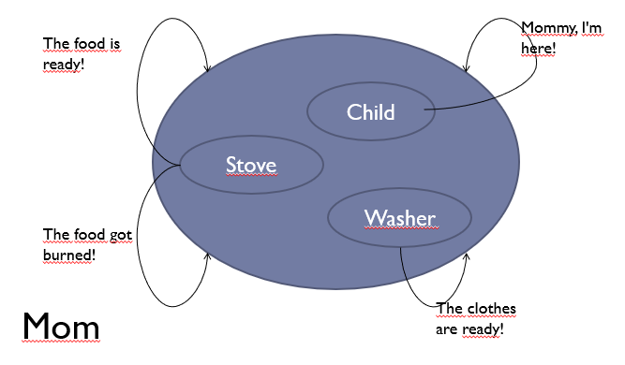

Task 1

Establishment of initial values of the entities, washing machine, stove and son. Running the program will return the results only with these conditions.

Initial values will be entered via a graphical display.

Task 2

Variation on the stove, the food may be longer than the time necessary to cook, if the mother does not turn off the stove.

When the food is ready, the mother must stop what she is doing to avoid burning herself.

# Record your notes/research here:

The student must document the creation of the threads, their life cycle, establishment of times, stops, notifications and synchronizations, as well as the reasons for their establishment in this way. To complement the information, review the corresponding assignment in Moodle (Project Based Learning: Mom case).

# Outline the steps/plan for your project:

The program must be modularized, in the future, there will be modifications.

It is important that if you need more information, you request it before starting to program, raise your requirements (Software requirements specification).